**Interactive 3D Virtual Tour API**

**Compiling:**

Download the codebase and use the following commands to compile using MVN:

1. Unzip the folder
2. Go to the root of the folder
3. Open **CMD** in the folder
4. Type **mvn compile** to compile the api
5. Package the project with command **mvn clean package**

This will create jar file in **/target** folder

**Run API:**

To run the API, do the following

1. Copy **application.properties** file & open with editor
2. Change database details accordingly
3. Save the file
4. Open **CMD**
5. Type **java -jar interractive3dvirtualtours{version}-SNAPSHOT.java**

**To verify if the API is up:** Go to a browser and type: <http://127.0.0.1:8089/> and get the following:

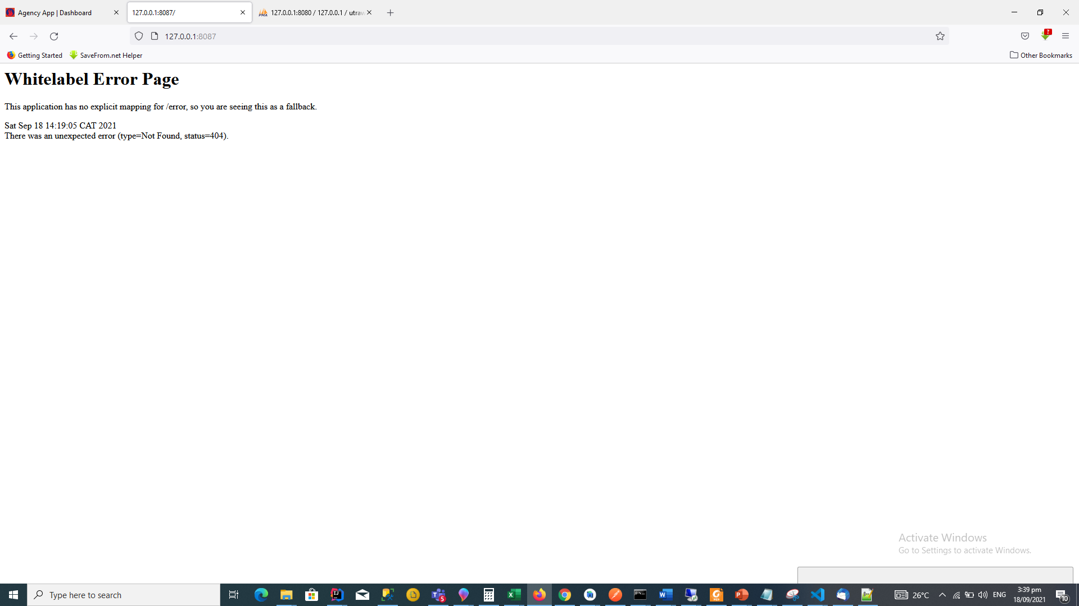

**TEST API WITH POSTMANE:**

|  |  |  |
| --- | --- | --- |
| **Endpoint** | **Request Type** | **Description** |
| /register | GET | Generate token |
| /register | POST | Add a registered member or edit existing member |

**Endpoint: /register (GET)**

**Sample Request**

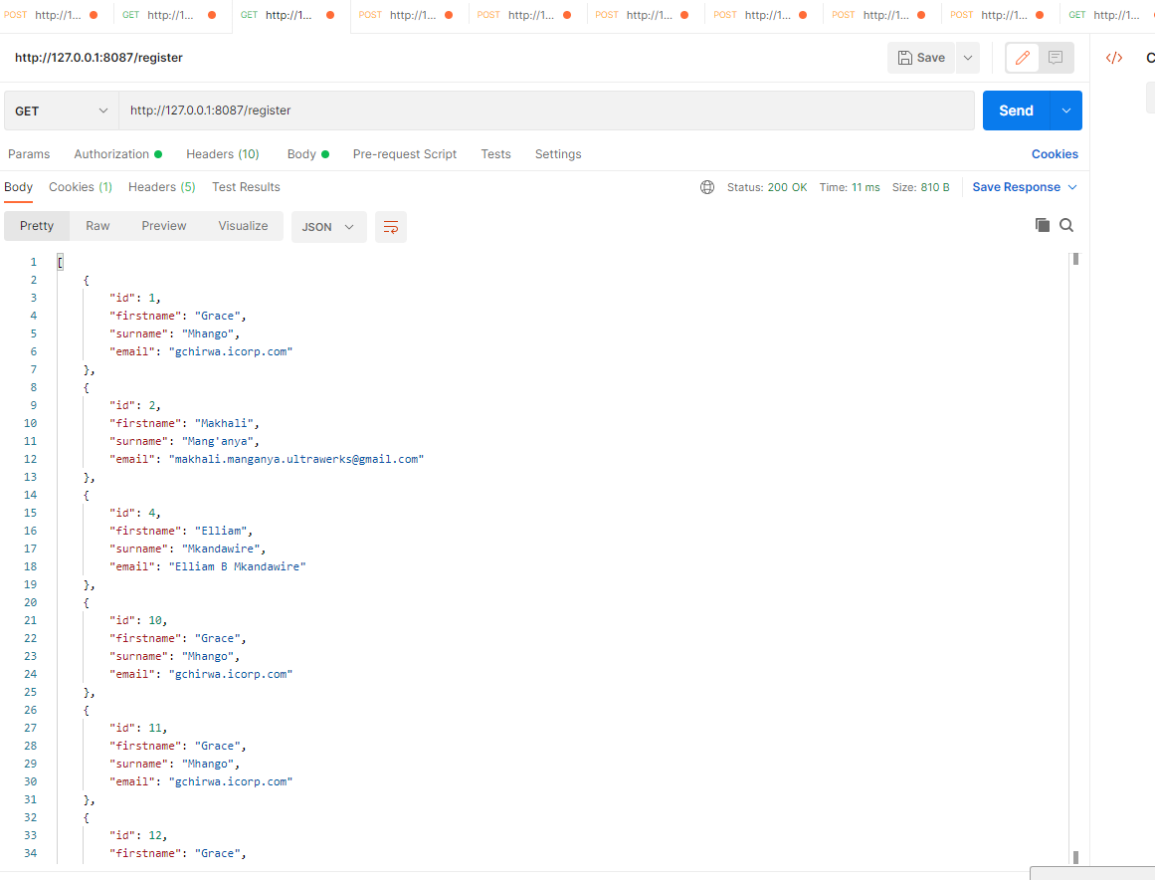

**Sample Request for /request (POST)**

POST NEW (Because ID is auto, to post new, don’t include it)

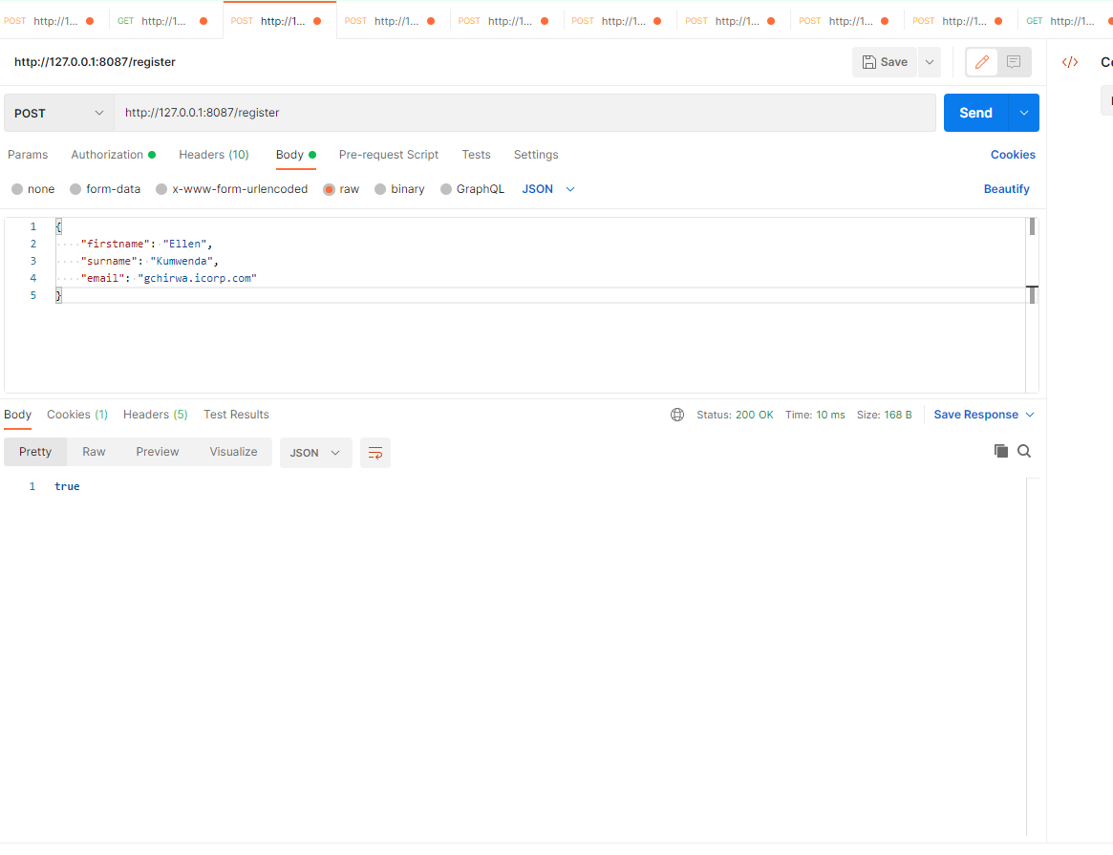

Figure : response is true when added successfully or n false if not added

­

**EDIT REGISTERED MEMBER (To edit, you add the id and post to the same endpoint)**

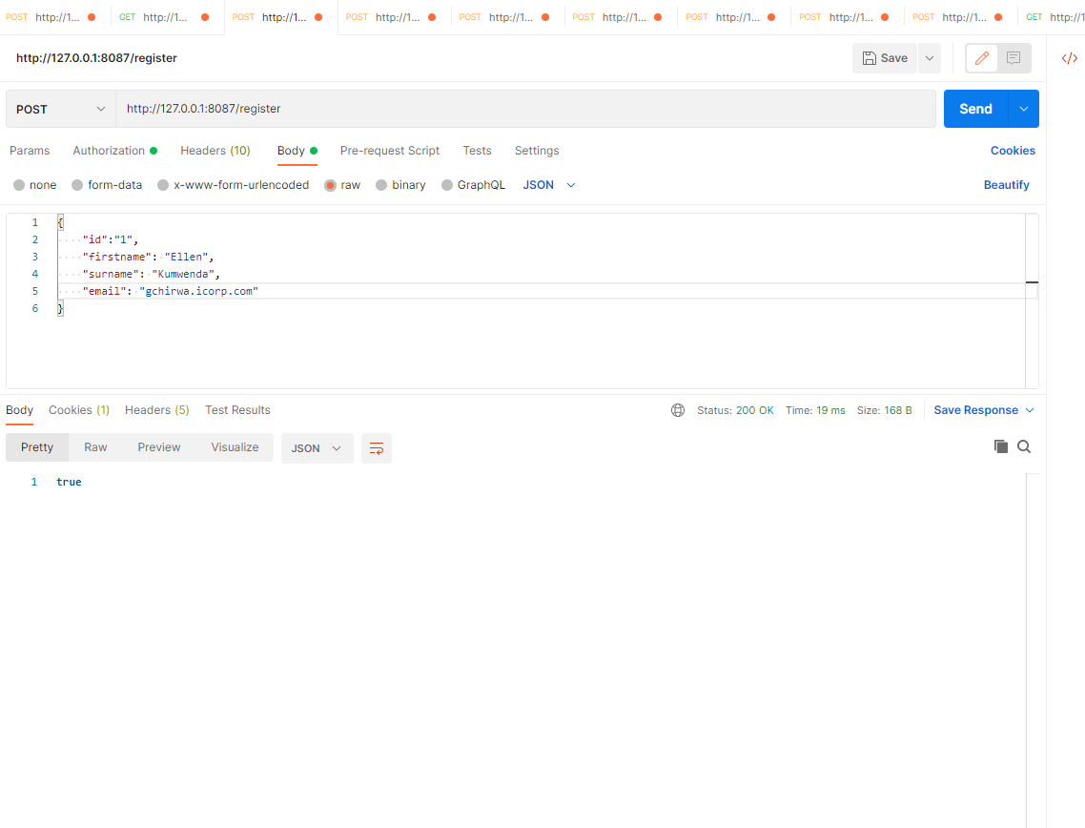

Figure : response is true if edited successfully­ or false otherwise